**Set Notation**

We need some notation to make talking about sets easier. Consider,

A={1,2,3}.

This is read, “A is the set containing the elements 1, 2 and 3.” We use curly braces “{,  }” to enclose elements of a set. Some more notation:

A ∈ {a,b,c}.

The symbol “∈” is read “is in” or “is an element of.” Thus the above means that a is an element of the set containing the letters a ,b, and c. Note that this is a true statement. It would also be true to say that d is not in that set:

D ∉ {a,b,c}.

Be warned: we write “x∈A” when we wish to express that one of the elements of the set A is x. For example, consider the set,

A = {1,b,{x,y,z},∅}.

This is a strange set, to be sure. It contains four elements:

the number 1,

the letter b,

the set {x,y,z}, and

the empty set ∅ = {}, the set containing no elements).

Is x in A? The answer is no.

None of the four elements in A are the letter x, so we must conclude that x∉A.

Similarly, consider the set B = {1, b}. Even though the elements of B are elements of A, we cannot say that the set B is one of the elements of A.

Therefore B∉A. (Soon we will see that B is a subset of A, but this is different from being an element of A.)

if we want A to be the set of all even natural numbers, would could write, A={0 ,2,4,6,…}, but this is a little imprecise. A better way would be

A = {x ∈ N: ∃ n ∈ N(x = 2n)}.

Breaking that down: “x ∈ N” means x is in the set N (the set of natural numbers, {0,1,2,…}), “:” is read “such that” and “∃ n ∈ N(x = 2n)” is read “there exists an n in the natural numbers for which x is two times n” (in other words, x is even). Slightly easier might be,

A={x : x is even}.

Note: Sometimes people use | or ∍ for the “such that” symbol instead of the colon.

##### **Example 2.1**

Describe each of the following sets both in words and by listing out enough elements to see the pattern.

00

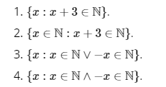

**Solution:**

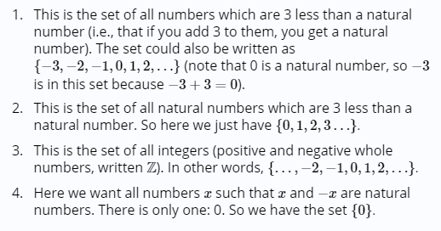

**Questions**

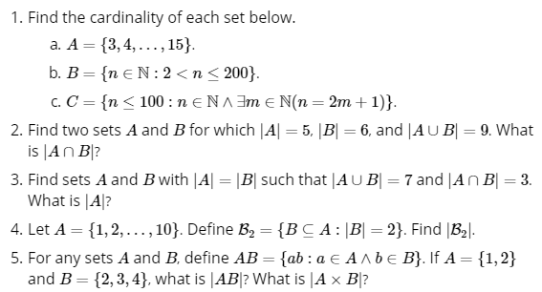

# Relationships between Sets

We have already said what it means for two sets to be equal: they have exactly the same elements. Thus, for example,

{1,2,3} = {2,1,3}.

(Remember, the order the elements are written down in does not matter.)

Also,



since these are all ways to write the set containing the first three positive integers (how we write them doesn't matter, just what they are).

What about the sets A = {1,2,3} and B = {1,2,3,4}? Clearly A≠B, but notice that every element of A is also an element of B. Because of this we say that A is a subset of B, or in symbols  A⊂B or  A⊆B. Both symbols are read “is a subset of.” The difference is that sometimes we want to say that A is either equal to or is a subset of B, in which case we use ⊆. This is analogous to the difference between < and ≤.

##### **Example 2.2**

Let A={1,2,3,4,5,6}, B={2,4,6}, C={1,2,3} and D={7,8,9}.

Determine which of the following are true, false, or meaningless.

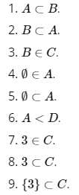

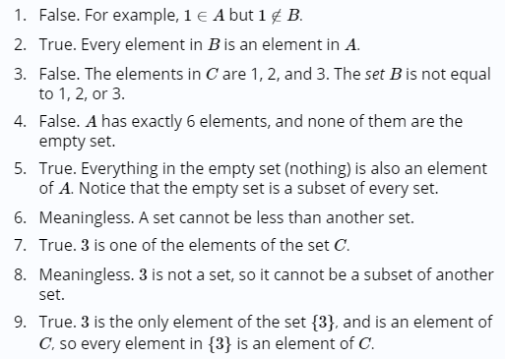

**Power Set**

In the example above, B is a subset of A. If we collect all these subsets of A into a new set, we get a set of sets. We call the set of all subsets of A the **power set** of A, and write it P(A).

##### **Example 2.3**

Let A={1,2,3}. Find P(A).

[**Solution**](http://discretetext.oscarlevin.com/dmoi/sec_intro-sets.html)

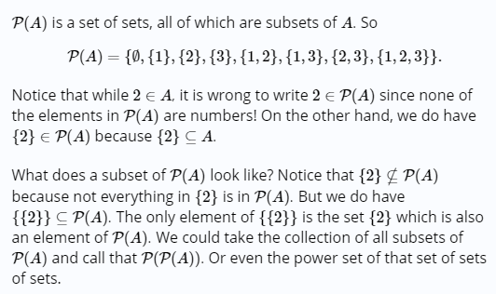

**Cardinality of Set**

Another way to compare sets is by their size. Notice that in the example above, A has 6 elements and B, C, and D all have 3 elements. The size of a set is called the set's **cardinality** . We would write |A|=6, |B|=3, and so on.

##### Example 2.4

1. Find the cardinality of A={23,24,…,37,38}.
2. Find the cardinality of B={1,{2,3,4},∅}.
3. If C = {1,2,3}, what is the cardinality of P(C)?

**Solution**

1. Since 38−23=15, we can conclude that the cardinality of the set is |A|=16 (we need to add one since 23 is included).
2. Here |B|=3. The three elements are the number 1, the set {2,3,4}, and the empty set.
3. We wrote out the elements of the power set P(C) above, and there are 8 elements (each of which is a set). So |P(C)|=8.

The notations is the set of all elements which are both elements of A and not elements of B, is known as **set difference** and represented by:



##### **Example 2.5**

Let A={1,2,3,4,5,6}, B={2,4,6}, C={1,2,3} and D={7,8,9}. If the universe is I ={1,2,…,10}, find:

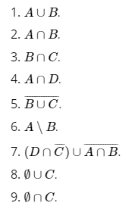

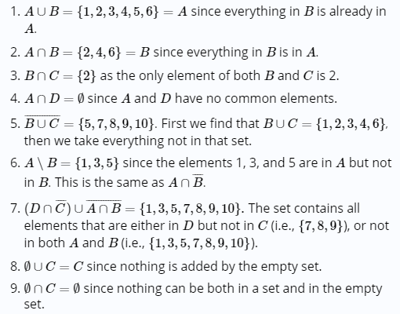

What does it mean for x to be an element of A∪B? It means that x is an element of A or x is an element of B (or both). This similar to logic symbols for “or” and “and.

That is,

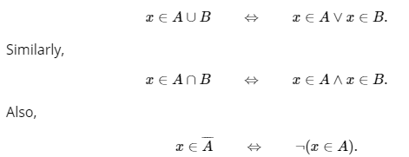

which says x is an element of the complement of A if x is not an element of A.

**Cartesian product**, A×A

A × A = {(a,b): a, b ∈ A} (we might also write A2 for this set).

##### **Example 2.6**

Let A = {1, 2} and B = {3, 4, 5}. Find  A × B and A × A. How many elements do we expect to be in B × B ?

**Amswer**

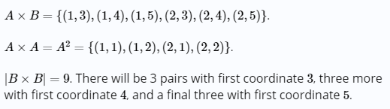

# Venn Diagrams

A **Venn diagram** displays sets as intersecting circles. We can shade the region we are talking about when we carry out an operation. We can also represent cardinality of a particular set by putting the number in the corresponding region.

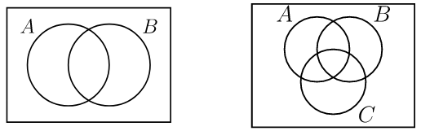

Each circle represents a set. The rectangle containing the circles represents the universe. To represent combinations of these sets, we shade the corresponding region. For example, we could draw

A∩B as:

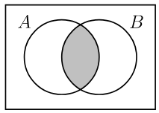

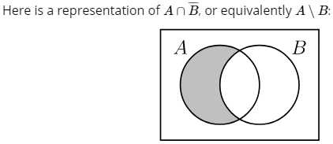

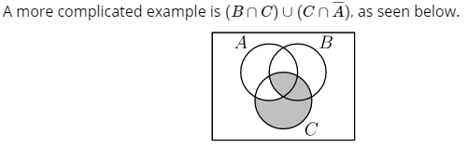

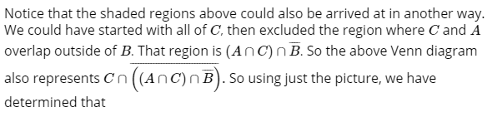



# Exercises

##### 1. Let A={1,2,3,4,5},  B={3,4,5,6,7}, and C={2,3,5}.

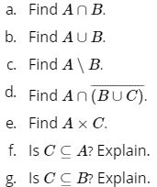

**Solution**

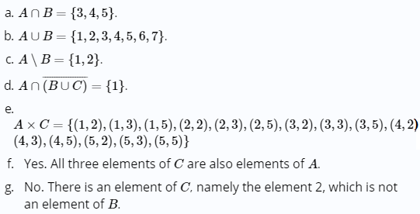



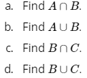

3. Find an example of sets A and B such that A∩B = {3, 5} and A∪ B = {2,3,5,7,8}.

##### 4. Find an example of sets A and B such that A ⊆ B and A ∈ B.

For example, A= {1,2,3} and B = {1,2,3,4,5,{1,2,3}}



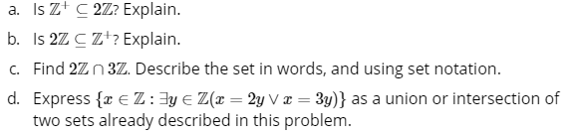

**Solution**

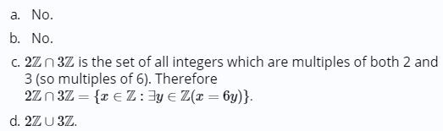

5. Draw a Venn diagram to represent each of the following:

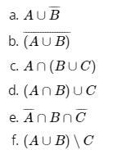

Solution

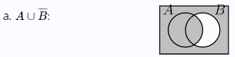

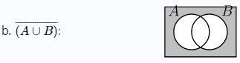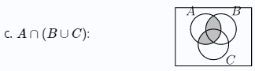

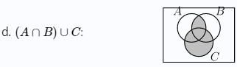

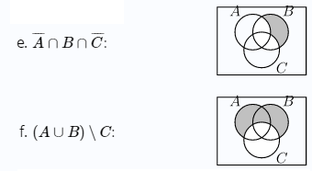

##### 6. Describe a set in terms of A and B (using set notation) which has the following Venn diagram:

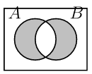

7. Find the following cardinalities:

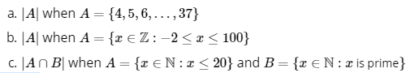

**Answer**

1. 34.
2. 103.
3. 8.

8. Let A={1,2,3,4,5,6}. Find all sets B∈P(A) which have the property {2,3,5}⊆B.

9. Find an example of sets AA and BB such that |A|=4, |B|=5, and |A∪B|=9.

For example,  A = {1,2,3,4} and  B = {5,6,7,8,9} gives A∪B = {1,2,3,4,5,6,7,8,9}.

##### **10.** Find an example of sets A and B such that |A|= 3, |B|= 4, and |A∪B|=5.

##### **11..** Are there sets A and B such that  |A|=|B|, |A∪B|=10, and |A∩B|=5?Explain.

**More examples with Venn diagram**

1. Draw and label a Venn diagram to represent the set

R = {Monday, Tuesday, Wednesday}.

***Solution:***  
  
2. Draw a circle or oval. Label it R . Put the elements in R.

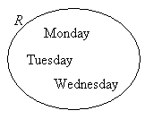

3. Given the set *P* is the set of even numbers between 15 and 25. Draw and label a Venn diagram to represent the set *P* and indicate all the elements of set *P* in the Venn diagram.

***Solution:***  
List out the elements of *P*.   
*P =*{16, 18, 20, 22, 24} ← ‘between’ does not include 15 and 25   
Draw a circle or oval. Label it *P* . Put the elements in *P*.

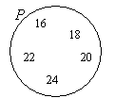

1. Given the set *Q* = {*x* : 2*x* – 3 < 11, *x* is a positive integer }. Draw and label a Venn diagram to represent the set *Q*.

***Solution:***  
Since an equation is given, we need to first solve for *x*.   
2*x* – 3 < 11 ⇒ 2*x* < 14 ⇒ *x* < 7

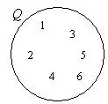

So, *Q* = {1, 2, 3, 4, 5, 6}

Draw a circle or oval. Label it *Q* .

Put the elements in *Q*.

1. **For A = {1, 2}, B = {2, 3}, U = {1, 2, 3, 4}, find the following using a Venn diagram:**

In terms of the elements:  {1,2}∪{2,3} Venn diagram:

A union B is shaded

Answer : **A**∪**B**=**{1**,**2**,**3}**

#### A∩B

In terms of the elements: {1,2}∩{2,3} Venn diagram:

A intersect B is shaded

Answer:  **A**∩**B**={**2**}

#### A​∁​​ (sometimes denoted as ~A or \footnotesize{\mathbf{\color{green}{ \neg A }}}¬A)